LDAP/TLS CONFIGURATION ON LINUX

192.168.0.180 ldapserver.hopto.org
192.168.0.181 ldapepas.hopto.org
192.168.0.182 ldapclient.hopto.org

yum -y install openldap-clients openldap-servers
systemctl start slapd
systemctl enable slapd
systemctl status slapd
Once installed, we have to generate a password for the admin user. In this example, we use a simple password: “redhat”
Slappasswd {SSHA}2qOMO8B2k5J3TtqbsrKLk+JOF/HwTPbu
New password:
Re-enter new password:
{SSHA}C5iN0R6Ra/CNyE+M0xNlYA9EPsgSu6HJ
Another, and maybe better, way to identify the data we require to create the LDIF file could be to use the ldapsearchcommand.
ldapsearch -Y EXTERNAL -H ldapi:/// -b cn=config olcDatabase=\*
We save the LDIF file with an appropriate name, for example, my_config.ldif, and we execute ldapmodify.
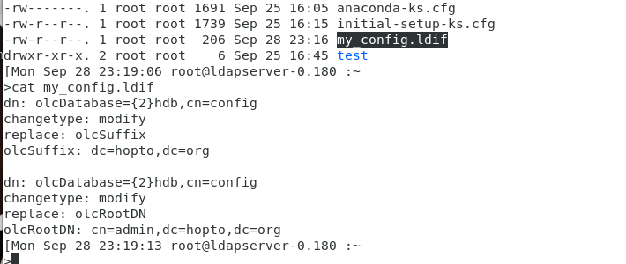
ldapmodify -Y EXTERNAL -H ldapi:/// -f my_config.ldif
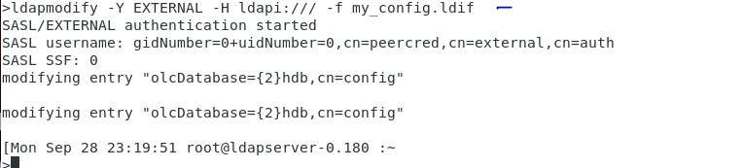
We could now see that the file is changed
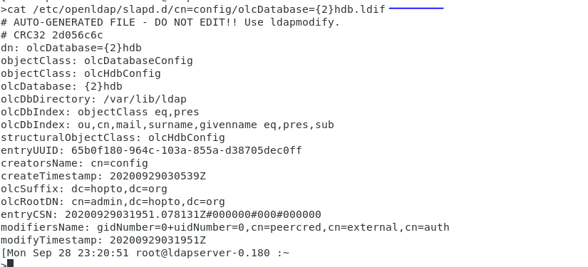
Add olcRootPW attribute
To add a new attribute we use "add" and then the attribute name as shown in the below example.
Here we create another LDIF file (my_config2.ldif) to add the olcRootPW attribute.

>cat my_config2.ldif
dn: olcDatabase={2}hdb,cn=config
changeType: modify
add: olcRootPW
olcRootPW: {SSHA}C5iN0R6Ra/CNyE+M0xNlYA9EPsgSu6HJ

we the run
ldapmodify -Y EXTERNAL -H ldapi:/// -f my_config2.ldif

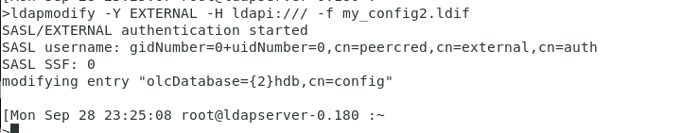

Replace olcAccess attribute
We also have to allow access to the LDAP database to the admin user we just specified before (cn=admin,dc=example,dc=com). If we take a look at the olcDatabase={1}monitor.ldif, file we’ll see the following line:
cd /etc/openldap/slapd.d/cn=config/
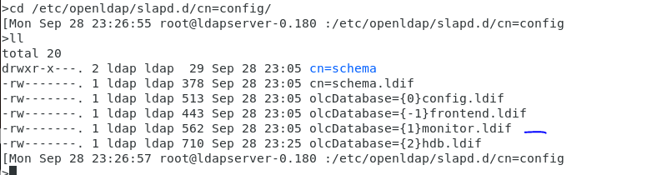

We’ll have to edit the file or use ldapmodify to change the entry. If we use ldapmodify, the LDIF file should be something like this:
cat my_config3.ldif
dn: olcDatabase={1}monitor,cn=config
changetype: modify
replace: olcAccess
olcAccess: {0}to * by dn.base="gidNumber=0+uidNumber=0,cn=peercred,cn=external, cn=auth" read by dn.base="cn=admin,dc=hopto,dc=org" read by * none

Once again, we execute ldapmodify by passing the new LDIF file as a parameter.
ldapmodify -Y EXTERNAL -H ldapi:/// -f my_config3.ldif

Validate the new attribute values
Now we can check with ldapsearch whether the value for the attribute was actually changed.
ldapsearch -Y EXTERNAL -H ldapi:/// -b cn=config olcDatabase=\* we see all the modification

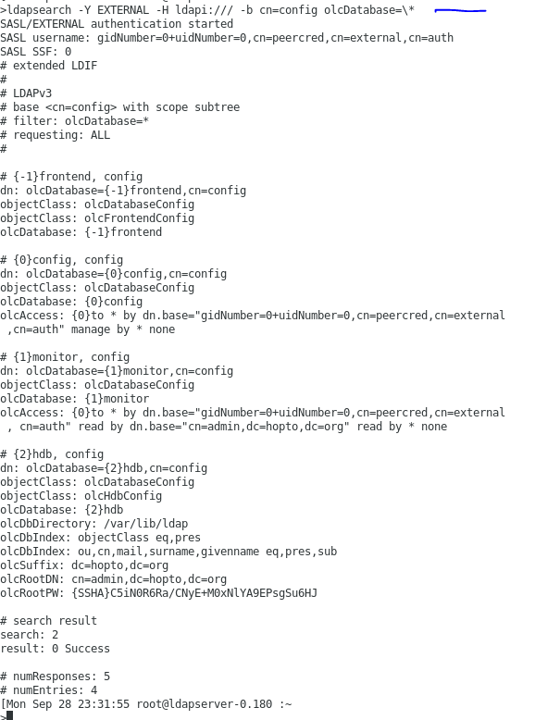

As we can see, the value was changed according to what we specified in the LDIF file.
Another tool we can use to check the configuration is the slaptest command.
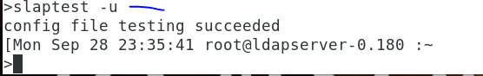

Adding Objects
Now we have to manually create an entry for dc=example,dc=com in our LDAP server. The easiest way to do this is to create an LDIF file for this entry and pass it to the ldapadd command.
So, we create a file named example.ldif, with the following content:
>cat example.ldif
dn: dc=hopto,dc=org
objectClass: dcObject
objectClass: organization
dc: hopto
o: hopto

We specify a series of attributes, such as distinguished name (dn), domain component (dc), and organization (o). We also define the new entry as an object of the type dcObject and organization.
Now we execute ldapadd and pass it the example.ldif file as a parameter. We specify with (-f) the name of the file, the admin user (-D), and the password we defined for that admin user (-w).
ldapadd -f example.ldif -D cn=admin,dc=hopto,dc=org -w postgres

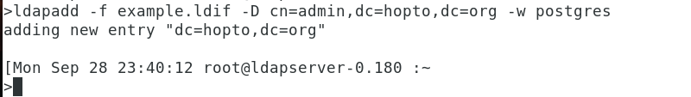

We can check whether the entry was created successfully by using the ldapsearch command.
ldapsearch -x -b dc=hopto,dc=org

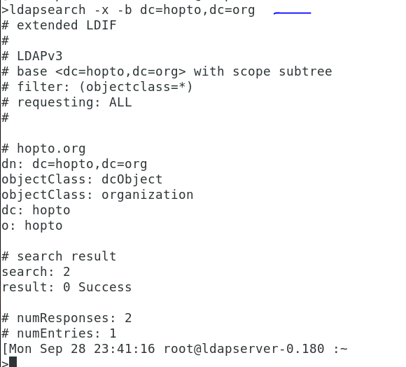

You just saw how to add the object dc=example,dc=com to our LDAP. Now you’ll see how to add organizational units , groups, and users.

Adding an Organizational Unit
Maybe we’d like to have an organizational unit (OU) called users in which to store all LDAP users. To do so, we’ll create a new LDIF file named users.ldif, with the following content:
>cat users.ldif
dn: ou=users,dc=hopto,dc=org
objectClass: organizationalUnit
ou: users

We execute ldapadd again to create the OU.
ldapadd -f users.ldif -D cn=admin,dc=hopto,dc=org -w postgres

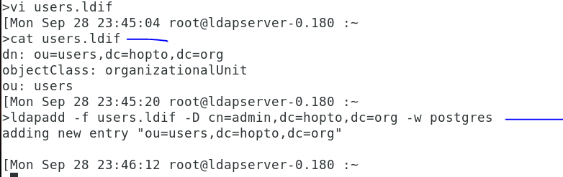

Adding a User
We can now include a user inside the organizational unit. The procedure is quite similar to what we have seen so far. First, we create a file named benson.ldif, with the following content:
>cat benson.ldif
dn: cn=benson of edb,ou=users,dc=hopto,dc=org
cn: benson
sn: edb
objectClass: inetOrgPerson
userPassword: postgres
uid: benson

Then we execute ldapadd again.
ldapadd -f benson.ldif -x -D cn=admin,dc=hopto,dc=org -w postgres

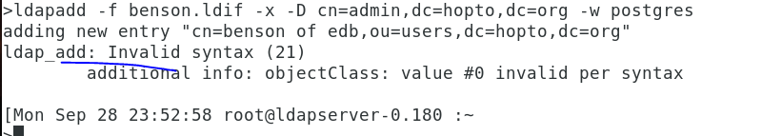

What this message means is that the object inetOrgPerson isn’t loaded in the core schema, so we’ll have to include it. In the /etc/openldap/schema folders, there are many LDIF files to extend the schema when we need it. We can see there is an inetorgperson.ldif file, which contains the schema definition for the inetOrgPerson object.
The schema itself is contained in the LDAP database, so we can add new definitions to it with the ldapadd command. As we’re going to modify the configuration itself, instead of the data, we’ll authenticate ourselves as the external root user (-Y EXTERNAL).
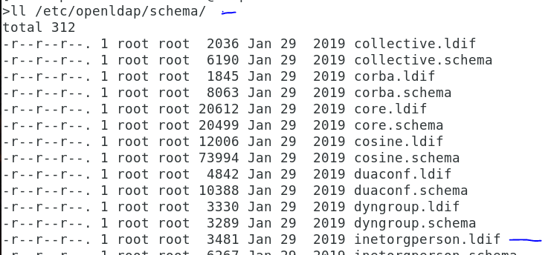

ldapadd -Y EXTERNAL -H ldapi:// -f /etc/openldap/schema/inetorgperson.ldif
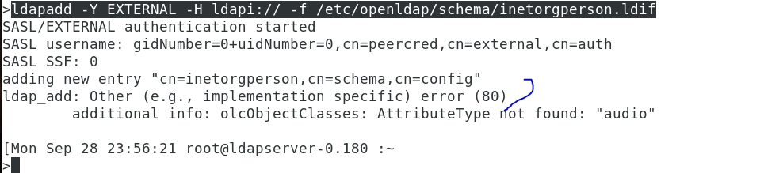

As we can see, we get an error, because the attribute type audio isn’t defined. So, we have to include this definition in the schema too .
If we perform a search of the string audio in the files located in the /etc/openldap/schema/ folder, we’ll see that the attribute audio is defined in the cosine.ldif file. So, we extend the schema with this LDIF file first.

ldapadd -Y EXTERNAL -H ldapi:// -f /etc/openldap/schema/cosine.ldif
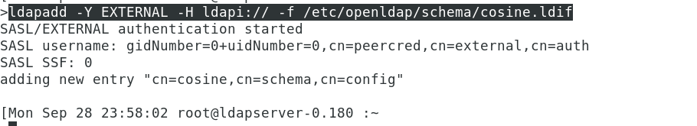

ldapadd -Y EXTERNAL -H ldapi:// -f /etc/openldap/schema/inetorgperson.ldif

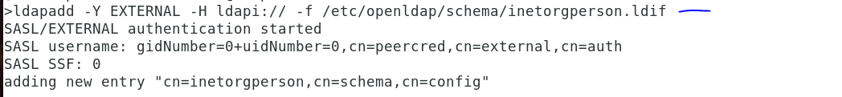\

Next we also add nis.ldif file

ldapadd -Y EXTERNAL -H ldapi:// -f /etc/openldap/schema/nis.ldif

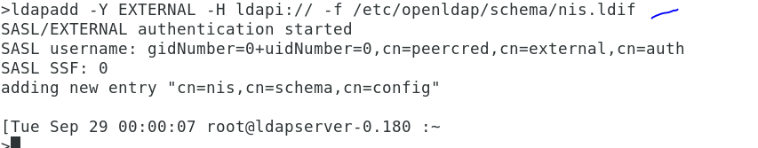

Now we can add the user with the benson.ldif file we created before.

ldapadd -f benson.ldif -x -D cn=admin,dc=hopto,dc=org -w postgres

If at some point we have to take a look at the currently used schema, we can use the slapcat command like this:

slapcat -b "cn=schema,cn=config" the output of this is large but look at the beginning and at the end.

Adding a Group
To add a group, we repeat the same process . First we create the group.ldif file with the following content:
>cat group.ldif
dn: cn=edbsupport,ou=users,dc=hopto,dc=org
cn: edbsupport
objectClass: groupOfNames
member: cn=benson of edb,ou=users,dc=hopto,dc=org

And we add the group with ldapadd.
ldapadd -f group.ldif -x -D cn=admin,dc=hopto,dc=org -w postgres

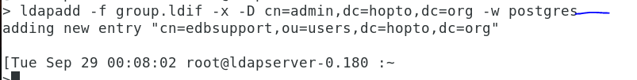

Now since our ldap server is configured, next we will configure openldap with TLS certificates

To configure OpenLDAP with TLS certificates we need openssl package. This will give us a directory hierarchy for creating the certificates to configure OpenLDAP with TLS certificates

yum -y install openssl

Create private key for CA certificate
First we need a private key to generate our own CA certificate. If you do not wish to have an encrypted private key then you can ignore -des3 in the below command:
openssl genrsa -des3 -out ca.key 4096
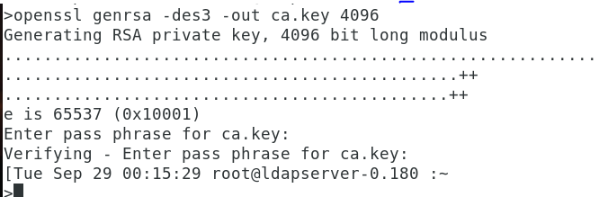

Generate CA Certificate
Next we will use our CA key to generate CA certificate. We will use this CA ceriticate later to sign the ldap client certificates
openssl req -new -x509 -days 365 -key ca.key -out ca.cert.pem
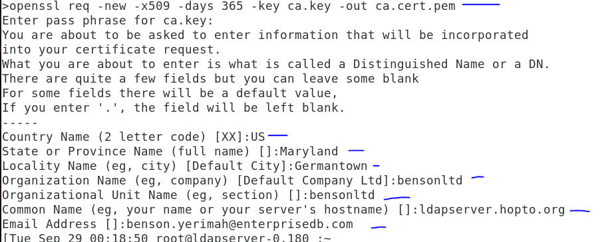
It is important that you provide a proper CN or else you will face problems with TLS handshake later as I have demonstrated in earlier articles. Here I am using the CN of my ldapserver.hopto.org.

Configure openssl x509 extension to create SAN certificate
We will create SAN certificate to avoid creating multiple certificates for each of our ldap client. You can learn more about SAN certificates at Create san certificate
>cat server_cert_ext.cnf
basicConstraints = CA:FALSE
nsCertType = server
nsComment = "OpenSSL Generated Server Certificate"
subjectKeyIdentifier = hash
authorityKeyIdentifier = keyid,issuer:always
keyUsage = critical, digitalSignature, keyEncipherment
extendedKeyUsage = serverAuth
subjectAltName = @alt_names
[alt_names]
IP.1 = 192.168.0.180
IP.2 = 192.168.0.182
IP.3 = 192.168.0.181
IP.3 = 192.168.0.183
DNS.1 = ldapclient.hopto.org
DNS.2 = ldapepas.hopto.org
DNS.3 = ldapserver.hopto.org

Under [alt_names], I will provide the complete list of IP Address and DNS name which the ldap client certificate should resolve when validating a client request.

Generate LDAP client key
Next we will need a ldap client key which we will name as "ldap.hopto.org.key"
openssl genrsa -out ldap.hopto.org.key 4096

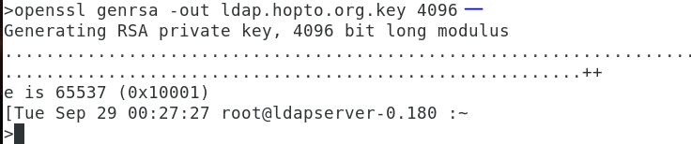

Create Certificate Signing request (CSR)
Next we need a CSR to sign our ldap client certificate. Here we will use our server configuration file to provide the list of IP and DNS. These values will be used as CN so all the clients with these IP or DNS will be allowed to establish TLS communication with the LDAP server
openssl req -new -key ldap.hopto.org.key -out ldap.hopto.org.csr
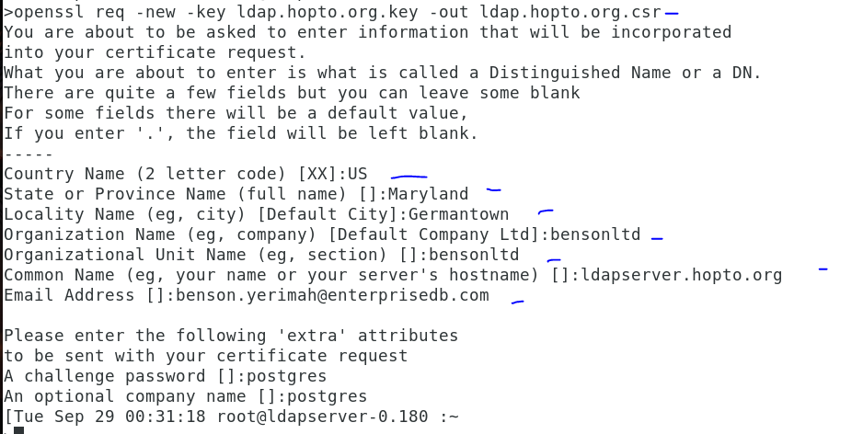

Create LDAP client certificate
Next we will create our ldap client certificate (ldap.hopto.org.crt) using the CSR, CA key and CA certificate we created earlier. This certificate will be valid for 365 days and is encrypted with sha256 algorithm.
openssl x509 -req -in ldap.hopto.org.csr -CA ca.cert.pem -CAkey ca.key -out ldap.hopto.org.crt -CAcreateserial -days 365 -sha256 -extfile server_cert_ext.cnf

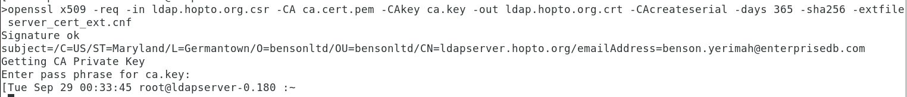

Verify the ldap client certificate
Next check the content of your ldap client certificate to make sure it contains the list of IP and DNS which we provided earlier.
openssl x509 -noout -text -in ldap.hopto.org.crt ---large ouput

After signing the certificate, we copy both the certificate and the key file to /etc/openldap/certs/. We also copy the CA certificate to /etc/openldap/cacerts/. Later, we’ll have to modify the openldap configuration accordingly.

cp -v ldap.hopto.org.crt ldap.hopto.org.key /etc/openldap/certs/
cp -v ca.cert.pem /etc/openldap/certs/

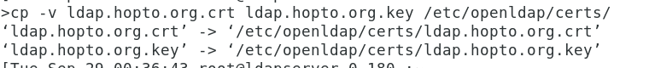

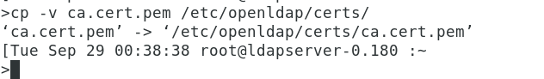

Securing the LDAP protocol
In CentOS 7, there are already default values for the TLS related attributes. We can see these values with slapcat.
slapcat -b "cn=config" | egrep "olcTLSCertificateFile|olcTLSCertificateKeyFile"

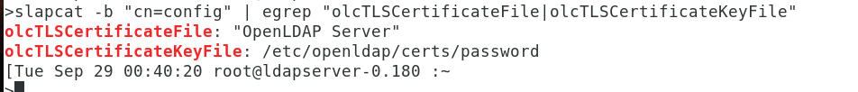

We have to modify the values of the olcTLSCertificateFile and olcTLSCertificateKeyFile attributes. So, we create the following LDIF file:

>vi tls7.ldif
[Tue Sep 29 00:43:00 root@ldapserver-0.180 :~
>cat tls7.ldif
dn: cn=config
changetype: modify
replace: olcTLSCertificateFile
olcTLSCertificateFile: /etc/openldap/certs/ldap.hopto.org.crt
-
replace: olcTLSCertificateKeyFile
olcTLSCertificateKeyFile: /etc/openldap/certs/ldap.hopto.org.key

Change the ownership of /etc/openldap/certs and and /etc/openldap/cacerts directory
chown -R ldap:ldap /etc/openldap/certs

And we run the ldapmodify command with this LDIF file .

ldapmodify -Y EXTERNAL -H ldapi:// -f tls7.ldif
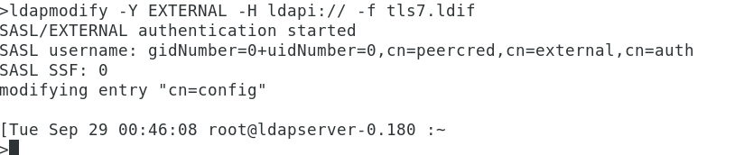

Next add a new attribute olcTLSCACertificateFile for CA certificate file. For this we will create another ldiff file
>vi tls7_1.ldif
[Tue Sep 29 00:48:01 root@ldapserver-0.180 :~
>cat tls7_1.ldif
dn: cn=config
changetype: modify
add: olcTLSCACertificateFile
olcTLSCACertificateFile: /etc/openldap/certs/ca.cert.pem

Then we run
ldapmodify -Y EXTERNAL -H ldapi:// -f tls7_1.ldif

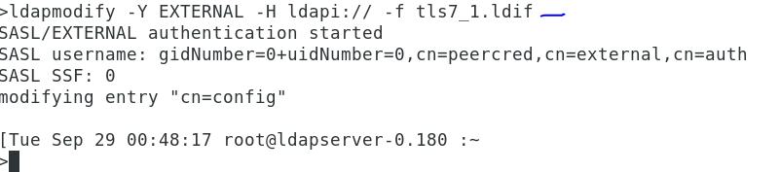

Validate the new values using slapchat.
slapcat -b "cn=config" | egrep "olcTLSCertificateFile|olcTLSCertificateKeyFile|olcTLSCACertificateFile"

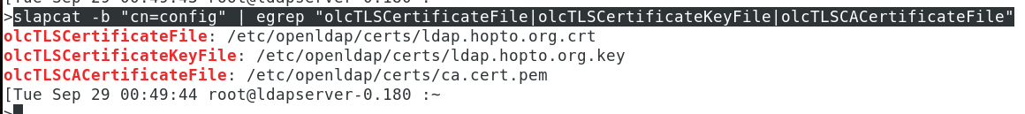

Now we edit the /etc/sysconfig/slapd file to add ldaps:/// to the SLAPD_URLS parameter
vi /etc/sysconfig/slapd

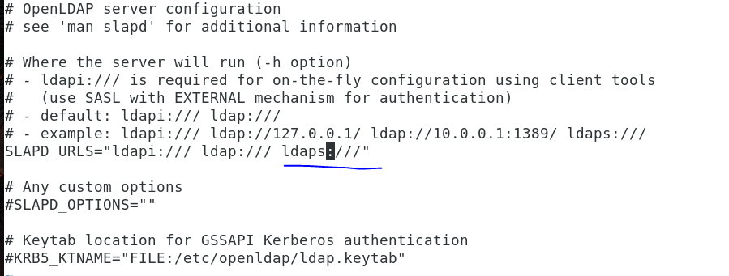

vi /etc/openldap/ldap.conf

TLS_CACERTDIR /etc/openldap/certs
TLS_CACERT /etc/openldap/certs/ca.cert.pem

Add the above in the file as below
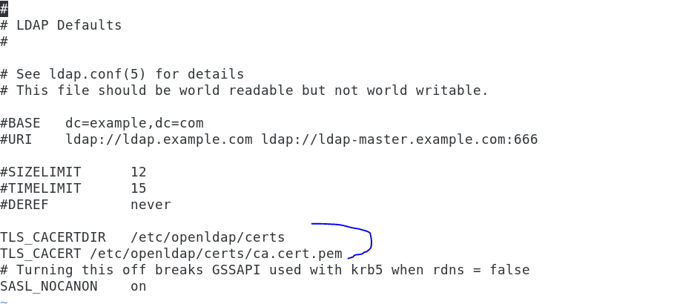

NOTE: Since we are using self signed certificate it is important to specify the CA certificate using TLS_CACERT or else you may get "TLS negotiation failure" during ldap client authentication. Alternatively you can choose to use TLS_REQCERT never for insecure communication and ignore any certificate checks

Then we restart the service to activate our changes

systemctl restart slapd
systemctl status slapd

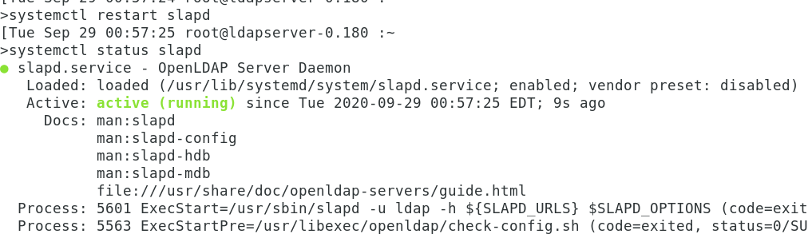

Validate TLS connectivity for LDAP
To make sure that TLS for LDAP is working properly, we can check it by passing the -ZZ option to ldapsearch.
Thus, we’re telling ldapsearch to establish a TLS connection.
ldapsearch -x –ZZ
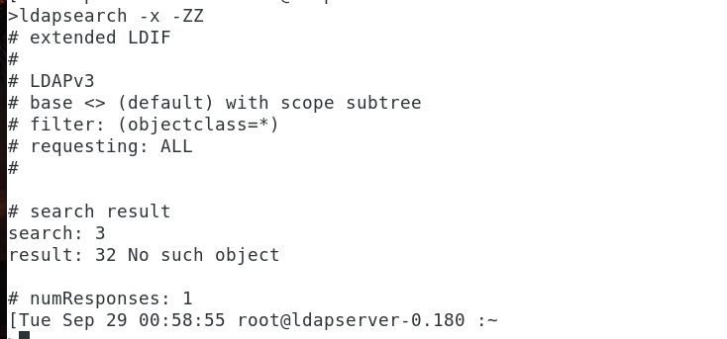

Now since we have our LDAP server is ready with TLS certificates, next we will configure ldap client to authenticate with ldap server

Install Openldap client packages on client or database server
First let us install all the required openldap client and dependent packages
Since we plan to use authconfig to configure ldap client for our RHEL/CentOS 7 Linux node, we only install SSSD and authconfig packages. oddjob-mkhomedir is required to be able to create active directory user's home directory automatically.

yum install authconfig authconfig-gtk openldap-clients sssd oddjob-mkhomedir.x86_64 –y

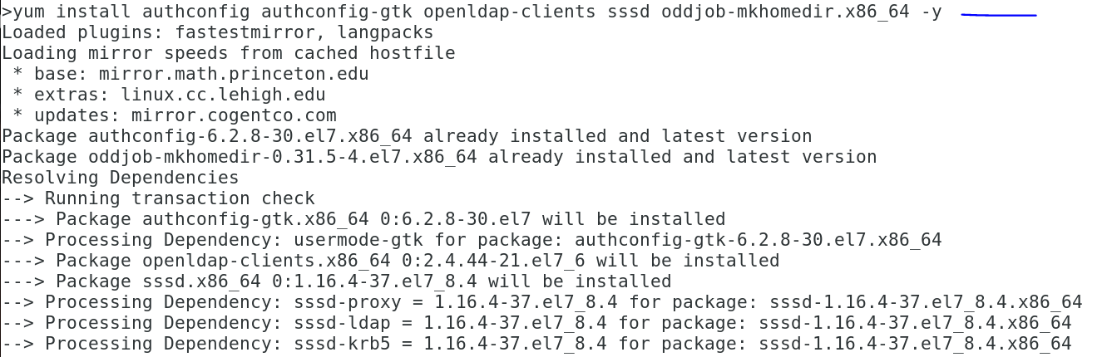

If you wish to configure LDAP client using nslcd, then you must install nss-pam-ldapd, pam_ldap. We will only use SSSD hence will not cover this part in our tutorial

Configure LDAP client or database server to authenticate with LDAP server. But in this case here, I will configure in server where database is running.
Before you start make sure you copy /etc/openldap/cacerts/ca.cert.pem from the ldap-server to ldap-client in the same location under /etc/openldap/cacerts/ca.cert.pem. This key will be referred by the authconfig tool
scp root@ldapserver.hopto.org:/etc/openldap/certs/ca.cert.pem /etc/openldap/cacerts/
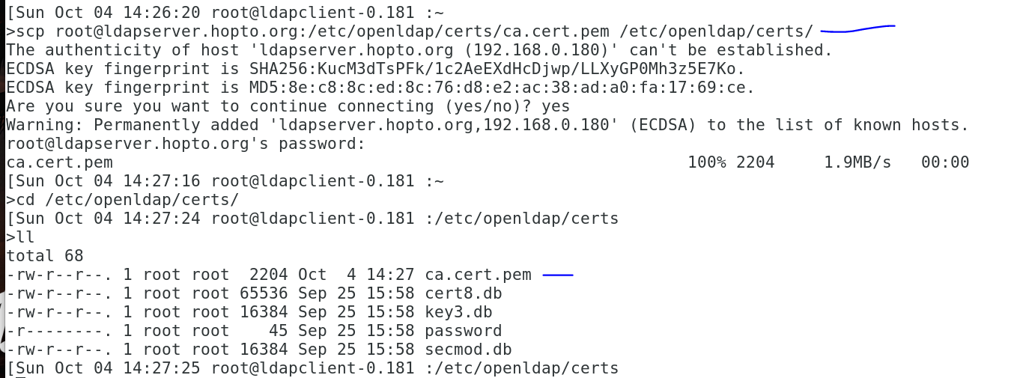

Method 1: Using authconfig-tui
Configuring a client system to use an LDAP directory for user authentication is as easy as pie on a Fedora or RHEL system. Fedora has command-line utilities as well as GUI tools (for example, system-config-authentication, authconfig-gtk) that make it easy.
One of the command-line tools is provided by the package authconfig. To launch the tool from the command line, type the following:
authconfig-tui

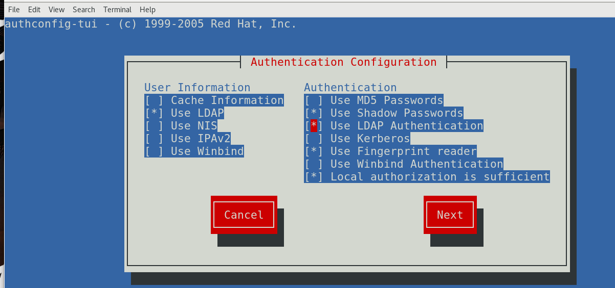
- In the Authentication Configuration screen, navigate to (using TAB on your keyboard) and then select (using SPACEBAR on your keyboard) the following:
Use LDAP → Under the User Information section
Use LDAP Authentication → Under the Authentication section

- Navigate to the Next button and press ENTER to select it.
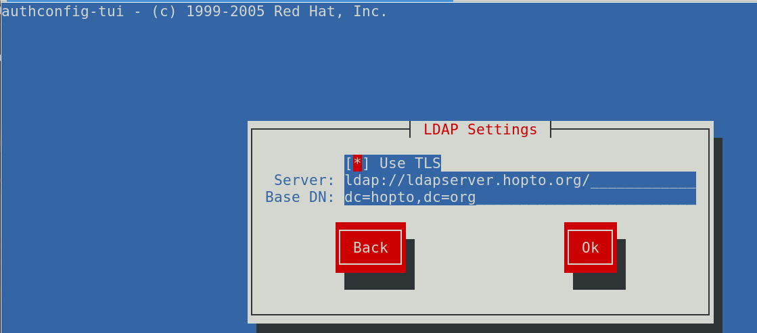
- Use the following information to complete the fields in the ensuing LDAP Settings screen:
As seen above, make sure you put the hostname. If you decide to use the ip address, tls will not work because the certificates did not define that.

Here 192.168.0.180 is the IP address of my ldap-server, replace it with your server details

- When we click OK, this will automatically change a series of files that otherwise would have to be changed by hand. For example, it will add the following lines to the /etc/openldap/ldap.conf file:

URI ldap:// ldapserver.hopto.org/
BASE dc=hopto,dc=org
TLS_CACERTDIR /etc/openldap/certs

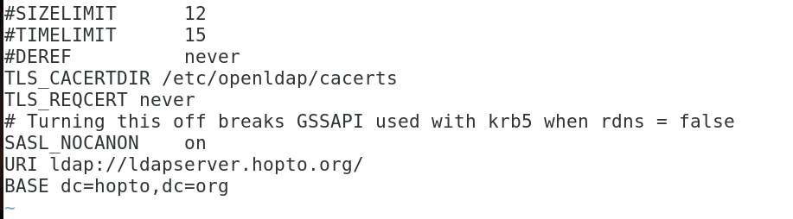

Open the file as shown and make sure you modify /etc/openldap/cacerts to /etc/openldap/certs as per my case

Add the following TLS_REQCERT nerver as seen below

Method 2: Using authconfig CLI
You can also configure ldap on the client using authconfig as shown below

[root@ldap-client ~]# authconfig --enableldap --enableldapauth --ldapserver=192.168.0.180 --ldapbasedn="dc=hopto,dc=org" --enableldaptls –update

Since we have already configured client using authconfig-tui, we will skip the configuration using authconfig.

If you get "Could not start TLS encryption. TLS: hostname does not match CN in peer certificate" error in /var/log/messages after restarting sssd then it means your client's hostname is not configured to use the CA certificate. In such case you must have a proper certificate generated for this client of use SAN certificate on the ldap server. Alternatively you can disable TLS check using TLS_REQCERT never in /etc/openldap/ldap.conf and also ldap_id_use_start_tls = False in /etc/sssd/sssd.conf. But this will disable the TLS communication hence making the system insecure.

Configure oddjob-mkhomedir to auto create home directories
We can use oddjob-mkhomedir to create home directories automatically for any ldap user which logs into the client node. This requires pam_mkhomedir.so provided by ddjob-mkhomedir which we had already installed earlier.
Modify the PAM configuration to use pam_oddjob_mkhomedir. For example, add this line at the bottom of /etc/pam.d/system-auth:
vi /etc/pam.d/system-auth
session required pam_oddjob_mkhomedir.so

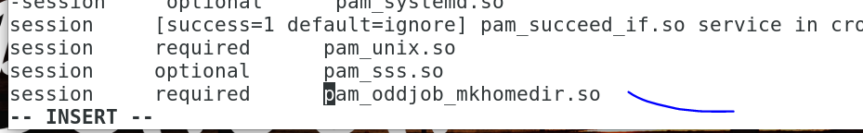

Next enable and start oddjobd.service
systemctl enable oddjobd.service –now
systemctl status oddjobd.service
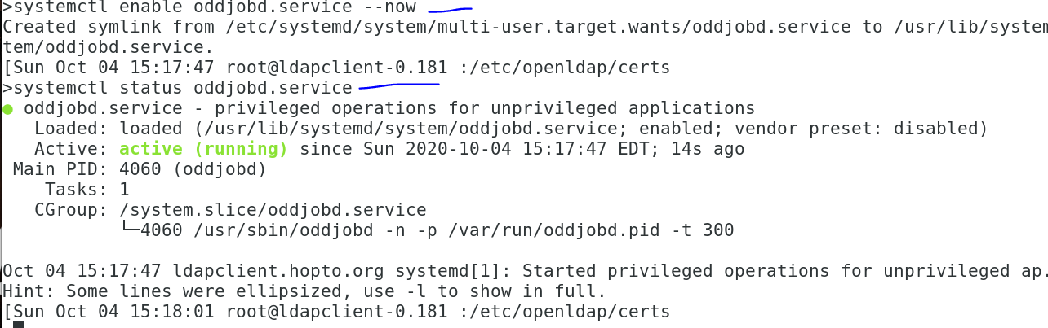

systemctl restart sssd.service
systemctl status sssd.service -l
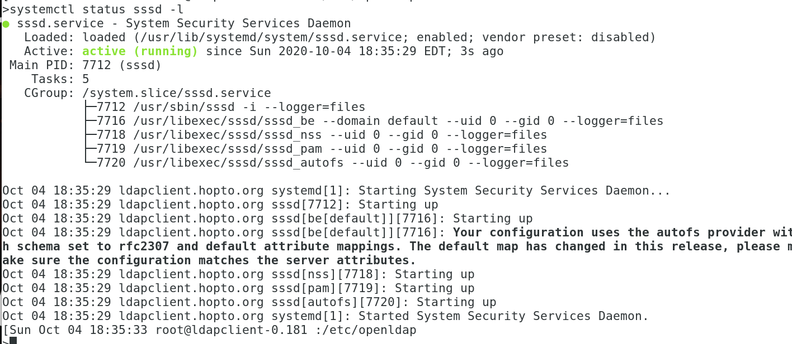
Make sure you run the status with the –l to make sure you don’t have errors

Create LDAP user (Optional)
You can ignore this step if you already a ldap user.
In order to authenticate as an LDAP user, when we create the user, we have to include a series of fields, such as shell, uid, gid, etc. As an example, let’s add the user edbuser. We begin by creating the edbuser.ldif file, with the following content:
ON MY LDAP SERVER, I DID THE FOLLOWING.

>user add edbuser
[Sun Oct 04 15:40:18 root@ldapserver-0.180 :~
[Sun Oct 04 15:40:21 root@ldapserver-0.180 :~
>su - edbuser
[edbuser@ldapserver ~]$ slappasswd
New password:
Re-enter new password:
{SSHA}6krwkeRuw9h+0fsIR6bdJ7d4dCOdjsK1
[edbuser@ldapserver ~]$

ON MY CLIENT, I CREATE THE FILES BELOW FOR THE USER

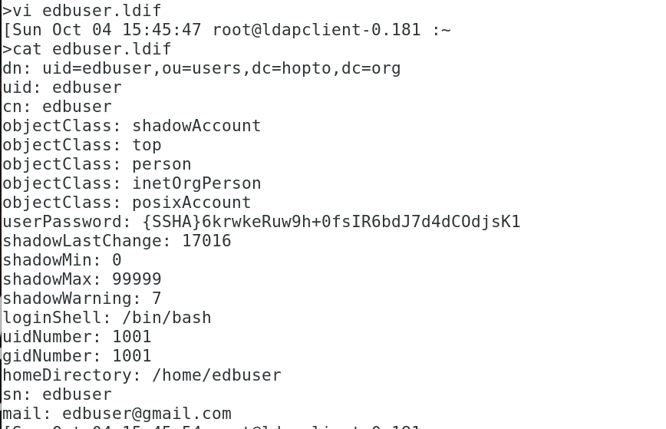

dn: uid=edbuser,ou=users,dc=hopto,dc=org
uid: edbuser
cn: edbuser
objectClass: shadowAccount
objectClass: top
objectClass: person
objectClass: inetOrgPerson
objectClass: posixAccount
userPassword: {SSHA}6krwkeRuw9h+0fsIR6bdJ7d4dCOdjsK1
shadowLastChange: 17016
shadowMin: 0
shadowMax: 99999
shadowWarning: 7
loginShell: /bin/bash
uidNumber: 1001
gidNumber: 1001
homeDirectory: /home/edbuser
sn: edbuser
mail: edbuser@gmail.com

As see above, I already created an encrypted password for edbuser using slappasswd on ldap-server node. My password for edbuser is postgres

Create LDAP group (Optional)
You can ignore this step if you already a ldap group.
Also we will need a group for this edbuser so I will add it to our existing OU "users"
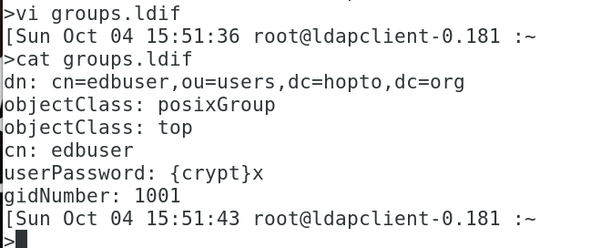

cat groups.ldif
dn: cn=edbuser,ou=users,dc=hopto,dc=org
objectClass: posixGroup
objectClass: top
cn: edbuser
userPassword: {crypt}x
gidNumber: 1001

Add user and group to LDAP database (Optional)
Add the users and groups to the ldap directory using the below commands
ldapadd -f edbuser.ldif -x -D cn=admin,dc=hopto,dc=org -w postgres
ldapadd -x -D cn=admin,dc=hopto,dc=org -f groups.ldif -w postgres

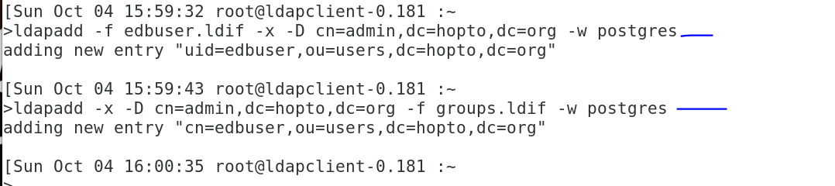

If you are getting ldap_add: Invalid syntax (21); additional info: objectClass: value #0 invalid per syntax while executing above command then you must load nis.ldif using
# ldapadd -Y EXTERNAL -H ldapi:// -f /etc/openldap/schema/nis.ldif
SASL/EXTERNAL authentication started
SASL username: gidNumber=0+uidNumber=0,cn=peercred,cn=external,cn=auth
SASL SSF: 0
adding new entry "cn=nis,cn=schema,cn=config"
and then re-try the ldapadd command for user/group.

Validate the new user and group (Optional)
Run the ldapsearch command again and verify users and groups are listed under the base DN to complete the configuration.
ldapsearch -x -D cn=admin,dc=hopto,dc=org -b dc=hopto,dc=org -w postgres
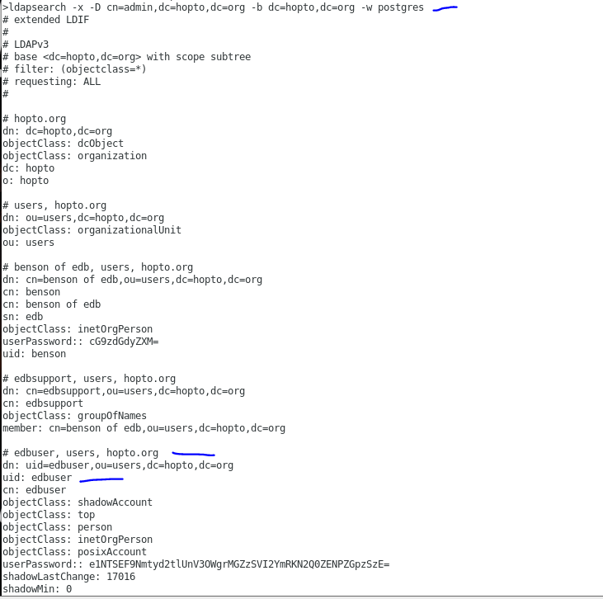

Connect via LDAP User
Since we have installed oddjob, so we don't need to create ldap user's home directory manually and it will created during the first login of the user. Now we’ll be able to authenticate with an LDAP user
su – edbuser
whoami

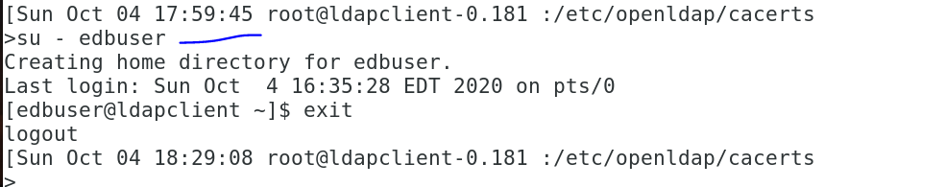

If your not able to su as the user, you can restart sssd

Next is the installation of postgres

yum -y install https://dl.fedoraproject.org/pub/epel/epel-release-latest-7.noarch.rpm
yum -y install https://yum.enterprisedb.com/edb-repo-rpms/edb-repo-latest.noarch.rpm
sed -i 's/<username>/benson.yerimah/g' /etc/yum.repos.d/edb.repo
sed -i 's/<password>/FDQsxz8UnheMvcUti/g' /etc/yum.repos.d/edb.repo

y
-y
/usr/edb/as12/bin/edb-as-12-setup initdb
systemctl start edb-as-12

su – enterprisedb
:> .bash_profile
vi .bash_profile
export PGDATA=/var/lib/edb/as12/data
export PATH=/usr/edb/as12/bin:$PATH
export PGDATABASE=edb
export PGUSER=enterprisedb
export PGPORT=5444
export PGHOME=/var/lib/edb
export PGLOCALEDIR=/usr/edb/as12/share/locale

vi pg_hba.conf
host all all 0.0.0.0/0 ldap ldapserver=192.168.0.180 ldapport=389 ldaptls=1 ldapprefix="uid=" ldapsuffix=",ou=users,dc=hopto,dc=org"

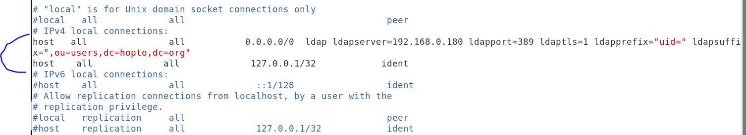

Test connection from same hosts..

psql -h ldapclient.hopto.org -d edb -U edbuser
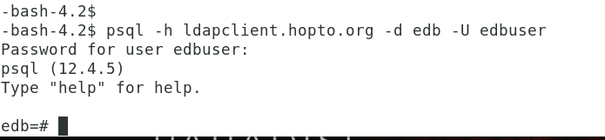
TESTING THIS SAME CONNECTION FROM ANOTHER CLIENT SERVER WITH NO SETUP.. JUST psql utility installed.

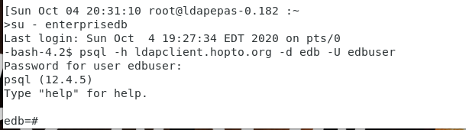

This works fine.

TEST CASE AND ADDING USER.
psql -h ldapclient.hopto.org -d edb -U yerima
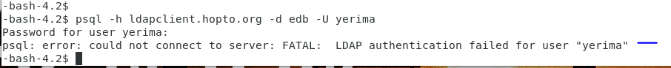

Inorder to get the above user to login, first I add the user in the postgres server (database)
create role yerima with login superuser password 'postgres';
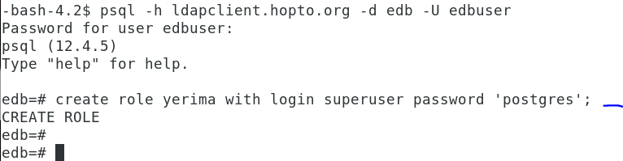

Note that even after creating the user, I cant login.

Next step will be to add the user in ldap server
On the ldap server, I added the user and created the password.

[Sun Oct 04 21:01:22 root@ldapserver-0.180 :~
>useradd yerima
[Sun Oct 04 21:01:28 root@ldapserver-0.180 :~
>su - yerima
[yerima@ldapserver ~]$ slappasswd
New password:
Re-enter new password:
{SSHA}KO6401S2IL/TgkIYU3u6DpoTF7KoYYnX
[yerima@ldapserver ~]$ id
uid=1002(yerima) gid=1002(yerima) groups=1002(yerima) context=unconfined_u:unconfined_r:unconfined_t:s0-s0:c0.c1023
[yerima@ldapserver ~]$

Created the ldif file for yerima

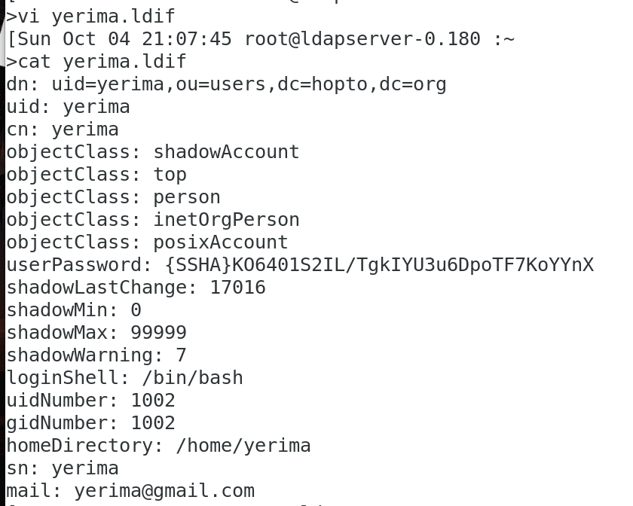

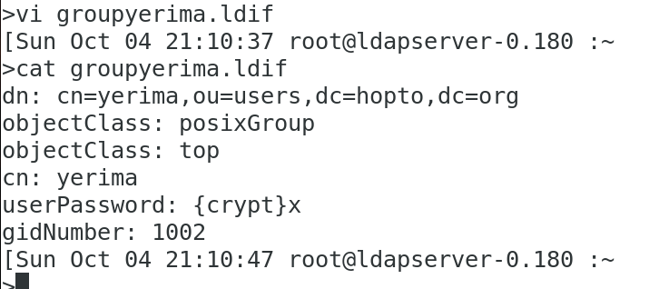
Now I add the user and group to the ldap database

ldapadd -f yerima.ldif -x -D cn=admin,dc=hopto,dc=org -w postgres
ldapadd -x -D cn=admin,dc=hopto,dc=org -f groupyerima.ldif -w postgres

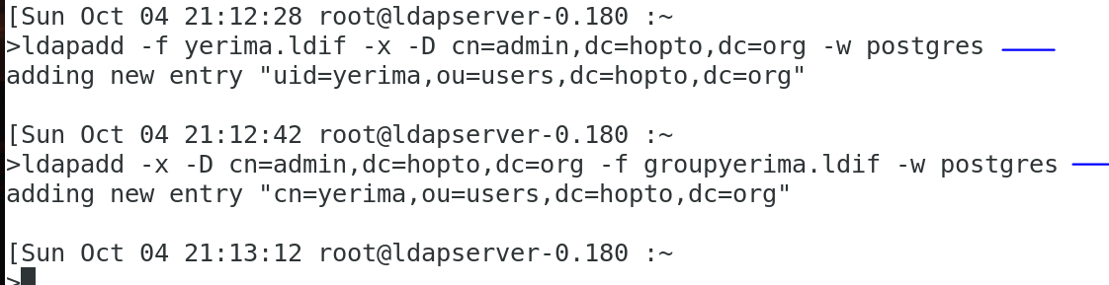

Now let’s test the connection again from another host.
psql -h ldapclient.hopto.org -d edb -U yerima

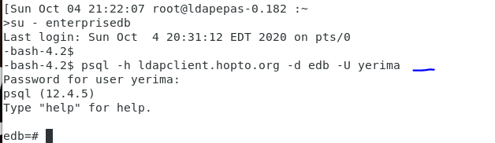

What if we setup streaming replication for the servers?

I was able to setup streaming replication with the following files setup on the master..

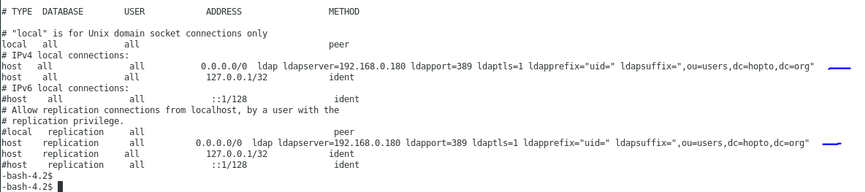

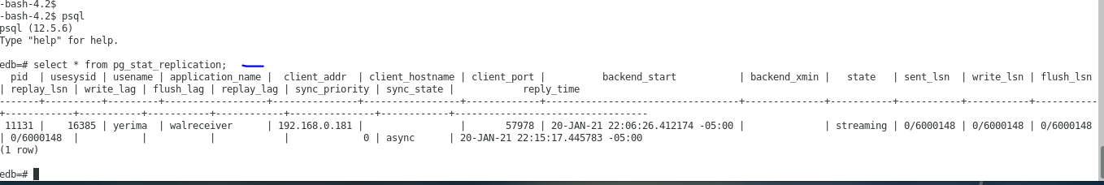

SO we could see that streaming replication is working fine but when we try to connect to the standby server, we get the error as seen below..

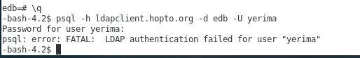

And this is because the standby server as needs to be setup to accept encrypted connections. So we need to setup and also copy the certs files to this server.
So we will need to repeat the following steps on the standby server.

Install Openldap client packages for standby
First let us install all the required openldap client and dependent packages
Since we plan to use authconfig to configure ldap client for our RHEL/CentOS 7 Linux node, we only install SSSD and authconfig packages. oddjob-mkhomedir is required to be able to create active directory user's home directory automatically.

yum install authconfig authconfig-gtk openldap-clients sssd oddjob-mkhomedir.x86_64 –y

Configure LDAP client or database server to authenticate with LDAP server. But in this case here, I will configure in server where database is running.
scp root@ldapserver.hopto.org:/etc/openldap/certs/ca.cert.pem /etc/openldap/cacerts/

Method 1: Using authconfig-tui
Configuring a client system to use an LDAP directory for user authentication is as easy as pie on a Fedora or RHEL system. Fedora has command-line utilities as well as GUI tools (for example, system-config-authentication, authconfig-gtk) that make it easy.
One of the command-line tools is provided by the package authconfig. To launch the tool from the command line, type the following:
authconfig-tui

- In the Authentication Configuration screen, navigate to (using TAB on your keyboard) and then select (using SPACEBAR on your keyboard) the following:
Use LDAP → Under the User Information section
Use LDAP Authentication → Under the Authentication section

- Navigate to the Next button and press ENTER to select it.
- Use the following information to complete the fields in the ensuing LDAP Settings screen:
As seen above, make sure you put the hostname. If you decide to use the ip address, tls will not work because the certificates did not define that.

Here 192.168.0.180 is the IP address of my ldap-server, replace it with your server details

- When we click OK, this will automatically change a series of files that otherwise would have to be changed by hand. For example, it will add the following lines to the /etc/openldap/ldap.conf file:

URI ldap:// ldapserver.hopto.org/
BASE dc=hopto,dc=org
TLS_CACERTDIR /etc/openldap/certs

Open the file as shown and make sure you modify /etc/openldap/cacerts to /etc/openldap/certs as per my case

Add the following TLS_REQCERT nerver as seen below

Configure oddjob-mkhomedir to auto create home directories
We can use oddjob-mkhomedir to create home directories automatically for any ldap user which logs into the client node. This requires pam_mkhomedir.so provided by ddjob-mkhomedir which we had already installed earlier.
Modify the PAM configuration to use pam_oddjob_mkhomedir. For example, add this line at the bottom of /etc/pam.d/system-auth:
vi /etc/pam.d/system-auth
session required pam_oddjob_mkhomedir.so

Next enable and start oddjobd.service
systemctl enable oddjobd.service –now
systemctl status oddjobd.service

Also restart sssd.service

systemctl restart sssd.service
systemctl status sssd.service -l
Make sure you run the status with the –l to make sure you don’t have errors
After the above configuration on the standby, everything works fine now..

